

How to Troubleshoot UNV Guard
Web Login Failure Issue

How to Troubleshoot UNV Guard Web Login Failure Issues

Description
This article describes how to troubleshoot UNV Guard Web login failure issues.
Note: This method is applicable to most of the scenarios encountered problems, if the method still cannot solve your problem, it is recommended to consult our Tech Support Team. https://global.uniview.com/Support/Service_Hotline/

Since different web login errors require different solutions, the following sections introduce the corresponding troubleshooting methods based on each specific error message.

Scenario 1 Username or password is invalid
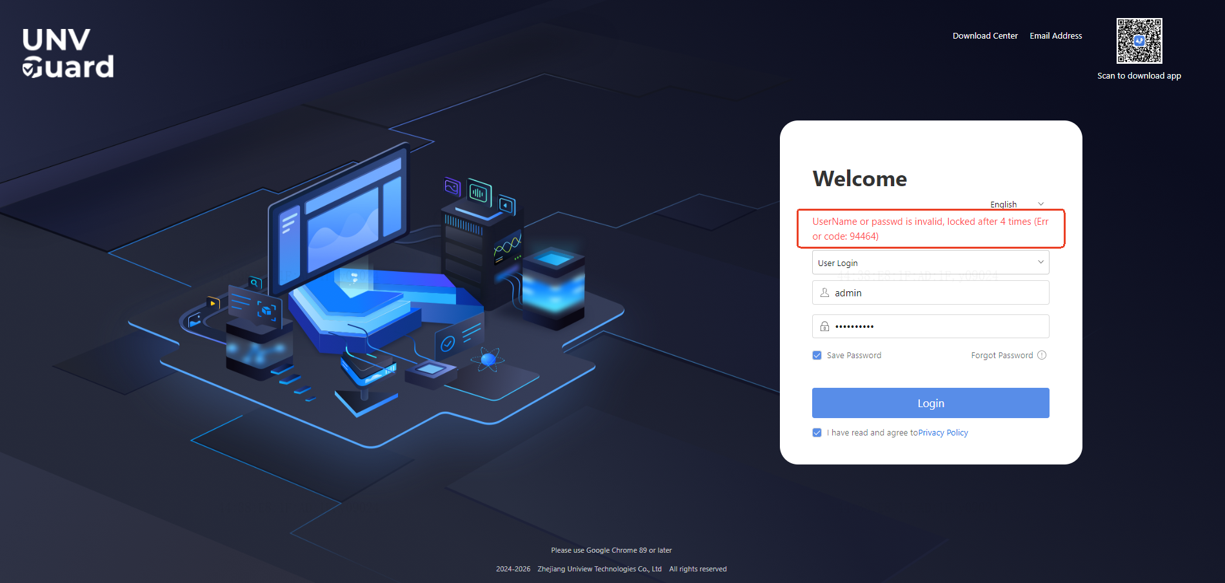

Solution:
Enter the correct username and password.
Note: If you have forgotten your password, click Forgot Password below the username and password fields to recover your password through email verification and security questions.

Scenario 2 The Other Errors
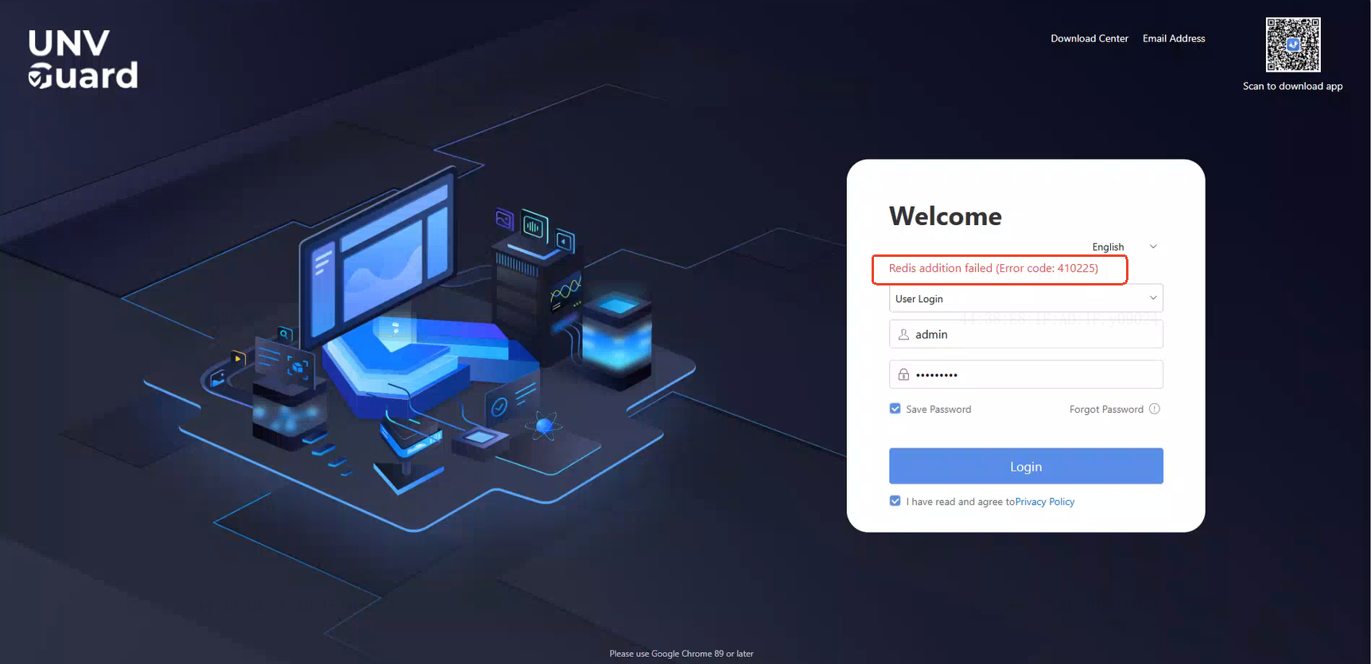
Error 1

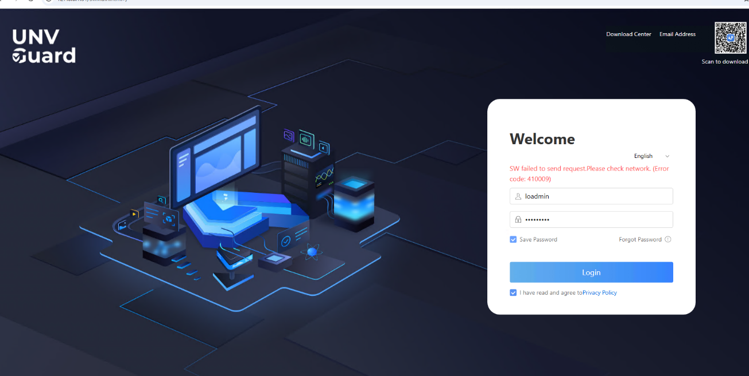
Error 2
Solution:

Reason 1 Service IP and NIC IP do not match
Please check whether the IP address of the UNV Guard service is consistent with the IP address of the network adapter on the server or PC where UNV Guard is installed.
- How to check the UNV Guard Service IP Address
- Navigate to UNV Guard\Server\framework\VM\vm_fuse\conf, open fusevm_cfg.yaml
Note: The disk containing this path is the disk where UNV Guard is installed.
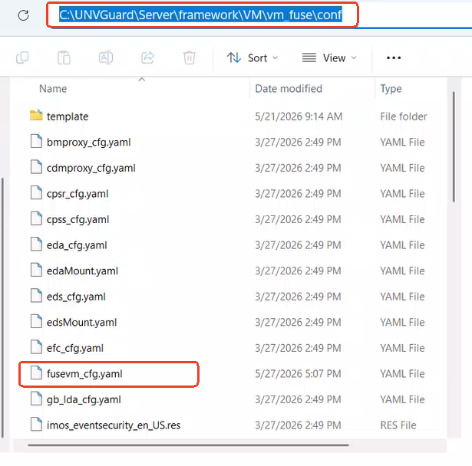

2) The Pod IP in this file is the service IP of UNV Guard.

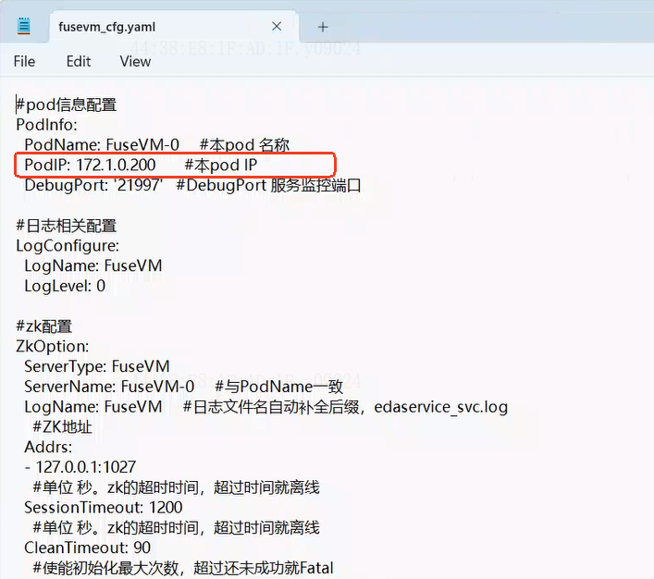

- How to check the network card IP Address of UNV Guard Server
- Press WIN + R simultaneously, enter cmd, and then press Enter.
- Enter ipconfig and press Enter. Then, you can view the network adapter IP address of the UNV Guard. 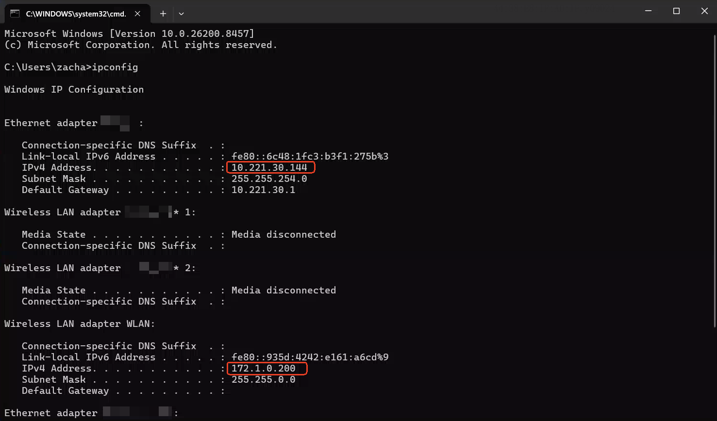
- If the UNV Guard server's NIC IP address is different from the service IP address, you need to modify the service IP address to match the NIC IP address.
- The modification method is as follows:
- Double-click the View UNV Guard Service Status icon on the UNV Guard server desktop to open the Service Manager interface.
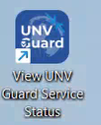
2) Click Change IP Address in the pop-up window, select the UNV Guard server's NIC IP address (a static IP address is required), then click Set as New IP. Wait for the services to restart.
Once the restart is completed, the service IP address will be successfully modified. When the service IP address matches the NIC IP address, you will be able to log in to the UNV Guard web page normally.

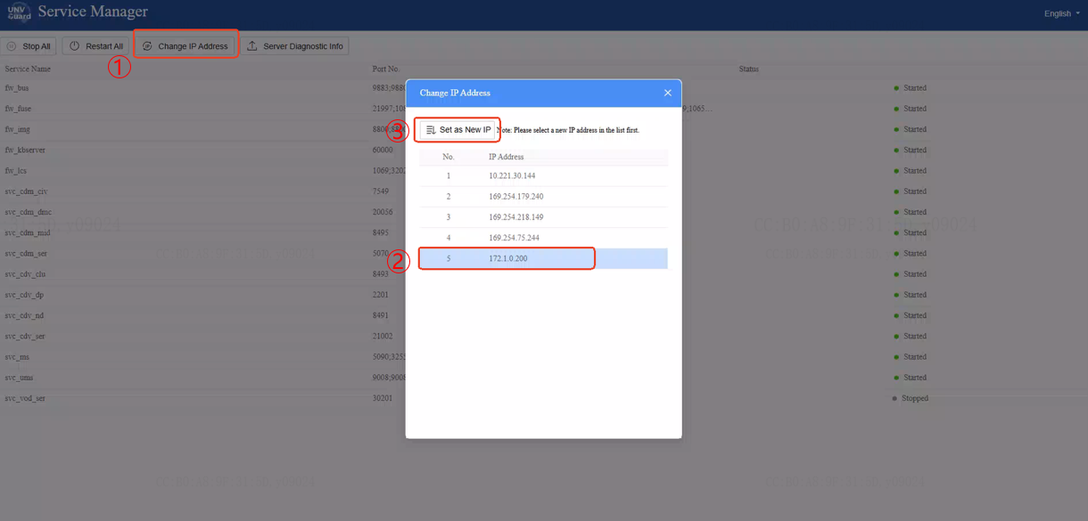

Reason 2 Port conflict or antivirus software
Sometimes, if other third-party software or antivirus software is installed on the UNV Guard server, the UNV Guard service may fail due to port conflicts or antivirus blocking, resulting in the inability to log in to the web page. The following methods can be used to check for port conflicts and antivirus interference.
- Click Download Center in the upper-right corner of the UNV Guard login page on UNV Guard Server.
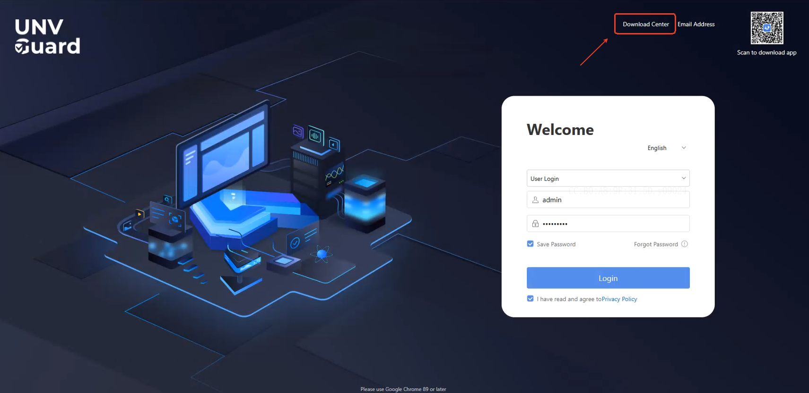

2. Click to download Env Diagnosis Tool.

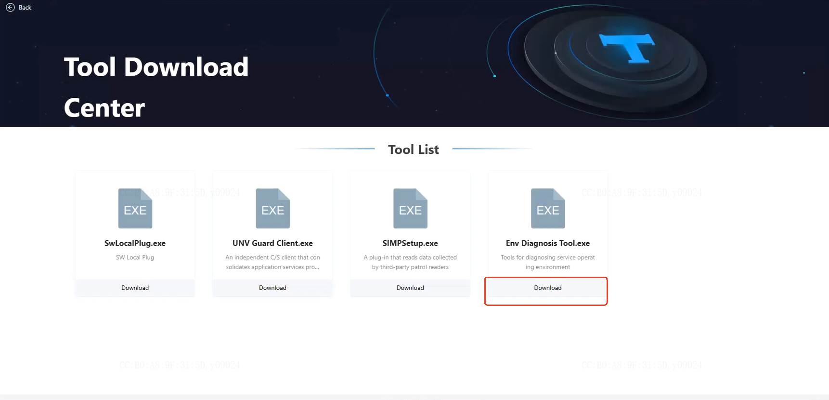

3. Double-click to run the tool, then click Start Detect in the pop-up window.
This tool will detect whether there are any third-party software applications or antivirus/security software on the UNV Guard server that may cause port conflicts or block the UNV Guard service from running. If any issues are detected, please consider uninstalling the third-party software causing the port conflict or adding the UNV Guard software to the whitelist of the antivirus/security software.
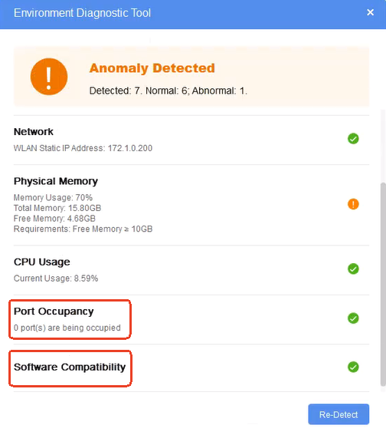

Scenario 3 Unable to open the web page
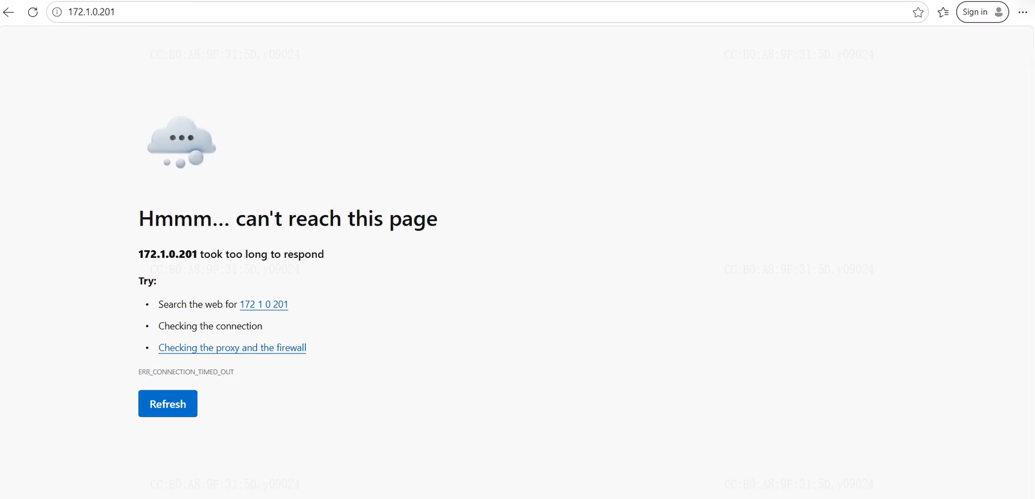

Solution:

Reason 1 Incorrect HTTP port
During installation, UNV Guard automatically adjusts the HTTP port to 80 or 81 based on the server environment. On the UNV Guard server, double-click the Web icon and check the address bar to view the HTTP port.
If no port number is displayed, the default HTTP port is 80. If :81 appears after the address, it means the HTTP port is 81. In this case, the client PC must use http://UNV Guard_IP:81 to log in successfully.

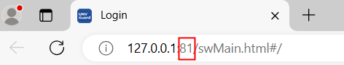

Reason 2 Network disconnected
When the network connection between the client PC and the UNV Guard server is unavailable, you may be unable to log in to the web interface. In this case, you can use the cmd window on the client PC to ping the UNV Guard server's IP address to check network connectivity. You can also log in to the UNV Guard server and verify whether local web access on the UNV Guard server is working properly.

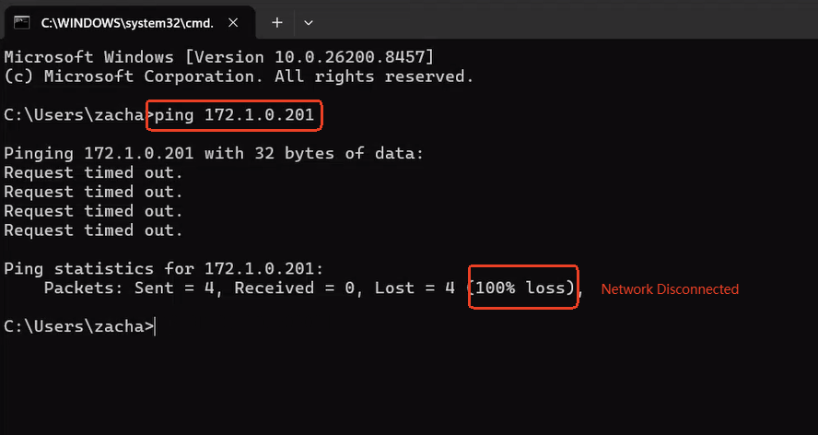

Reason 3 HTTP port unreachable
When network restrictions exist between the client PC and the UNV Guard server, the web page may fail to open because the HTTP port is unreachable. You can use the telnet command in the cmd window on the client PC to test whether the HTTP port is accessible. If the port is blocked, contact your network engineer to allow the required network port between the client PC and the UNV Guard server.
Note: Before using Telnet, make sure the Telnet feature is enabled on the client PC.

